Does mixed-mode data collection have influence to the quality of data of LFS?

Kirsti Pohjanpää**[1]**

Head of Development, Statistics Finland

Statistics Finland has made a web pilot survey of Labour Force Survey (LFS) to study the mode effect between web and CATI. In the pilot, the data of LFS was collected by web (based on a random sample of 8,000 Finns aged 15‒74), and then the received data was compared to the official data of LFS collected by telephone interviewing at the same time. We find no statistical significant differences between the main indicators of LFS. Yet more studies are needed to be sure about the quality of web data in LFS. There were a couple of split-plot tests in the web pilot, too. The two different ways of asking the number of hours worked during the reference week were reported here, and the grid form of question was recommended. The data collection of the pilot study was at October 2013, and the response rate was 30%. The project is part of the Eurostat ESSnet project *Data Collection for Social Surveys using Multi Modes.*

## **1. Introduction**

Statistics Finland made a web pilot study of Labor Force Survey (LFS) at October 2013. The main aim of this pilot was to find out if there is some mode effect between telephone interview (offical LFS) and web data collection (the pilot data). The project was a part of the Eurostat ESSnet project on *Data Collection for Social Surveys using Multiple Modes* (DCSS, 2012‒2014) [1,2], and Statistics Finland’s project set *Developing the web data collection in personal surveys* (2012‒2014).

## **2. The web pilot study of LFS**

The sample size of the web pilot study of LFS was 8,000, and it was a random sample of 15 to 74 year-olds Finns. We have the questionnaire only in Finnish (although we normally make all our interview questionnaires at least by Finnish and by Swedish). The data collected at October 2013 at the same time (nearly) as the “normal” LFS data.

The sample is divided into four parts (2,000 each) arise from the fixed reference weeks. In October there were five reference weeks (weeks 40–44), but because of some problem of coding the questionnaire we need to drop the first reference week out of the study. So, we started the data collection at 14th October. The last day of data collection was 21st November. (Fig 1.) The data collection time of each reference weeks was 2,5 weeks.

**Figure 1.** The reference weeks, and the time of data collection in the web pilot of LFS.



There were also some split plot tests in the pilot (Fig 2). One of them was connected to the DK option (not reported here), and two others related to the way how to ask the hours of worked, and what kind of way they have used when finding new job (not reported here). For the split plot arrangement the sample (all the single reference weeks) was divided still by two: group A and group B. The questionnaire of groups A and B was somehow different.

When analyzing the mode effect between web data collection and telephone interview (official LFS) we edit the LFS data a bit (1st and 2nd waves, 4 reference weeks, and Finnish-speaking only). Because of this, the results concerning to LFS in this pilot survey are not exact the same we have released, for example, in the website of Statistics Finland. The response rate of official LFS in October 2013 was 73.4% (the 1st wave).

The questionnaire was coded by Blaise IS, and it was made in a separate project in Statistics Finland [1].

**Figure 2.** The split plot test, and two groups of Finnish web pilot study of LFS.

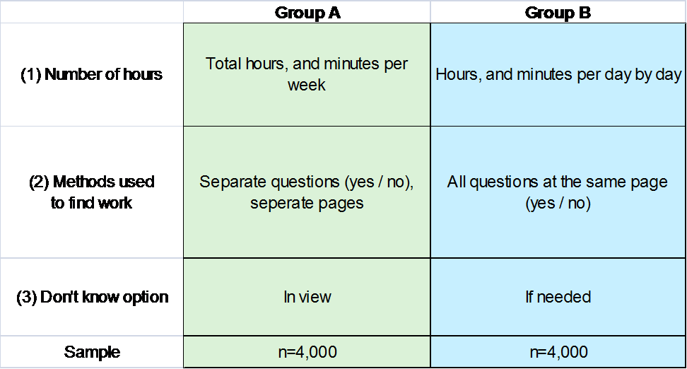

All the sample people got the advance letter by post at the very first day of data collection (on Monday, see Fig 3). In that post they got their personal usernames and passwords, too, to log in to the web questionnaire. After that there were one to two reminders for the non response. Those with telephone number got a motivation call or a text message at the first data collection week. The second reminder was a letter sending by post to all non response at the last week of data collection.

**Figure 3.** The data collection process of the web pilot of LFS, one reference week.

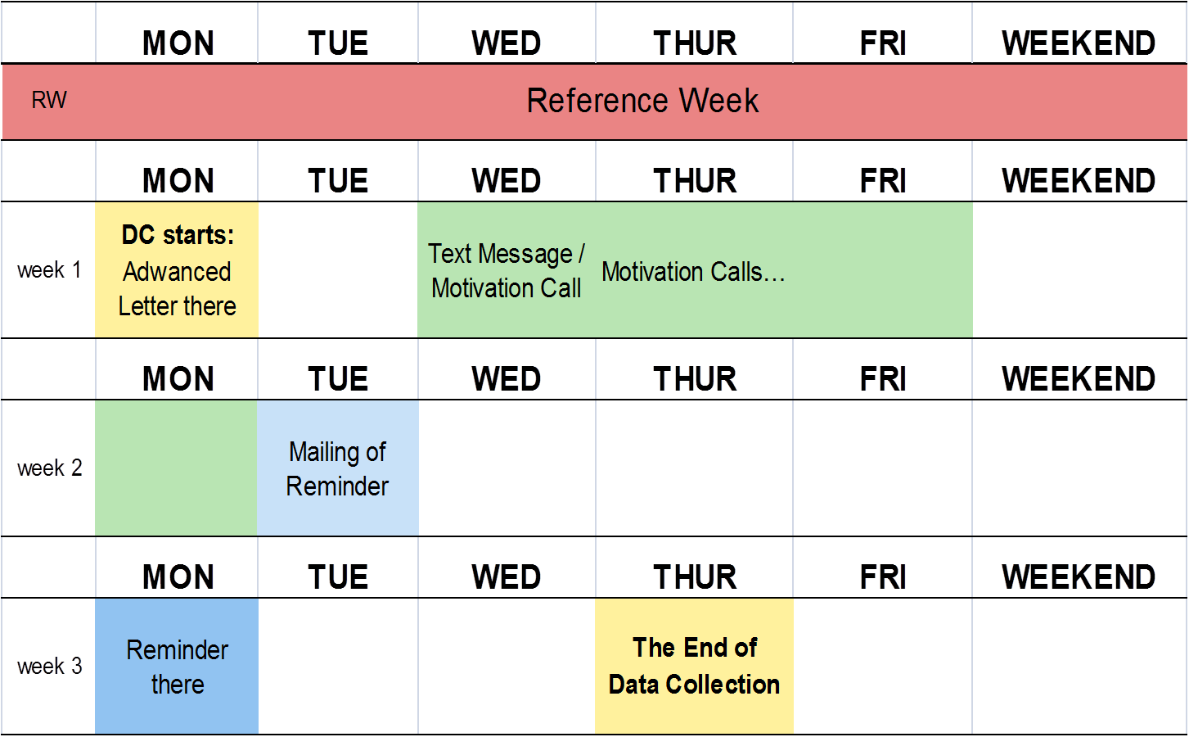

## **3. The Response Rate**

The response rate of the web pilot was 30%, and there are 2,366 complete answers in the data. The best response rate was for people 55 years old or older (Fig 4). Unfortunately those 15 to 24, and also 25 to 34 year-olds were the laziest to participate. In the telephone interview people in that age are either very eager to take part in the surveys like this, so web data collection will not help in that point the apprehension of diminishing of response rate.

Also people with low education were not very active to take part to the survey (Fig 5). The response rate among them were some half of the same rate of highly educated people.

To reduce the effects of non-response on the results the data was corrected by using weight calibration by area, gender, age and status in the job seeker register, as it is done also in the “normal” LFS in Finland.

**Figure 4.** The response rate by age in LFS data collected by web (October 2013).

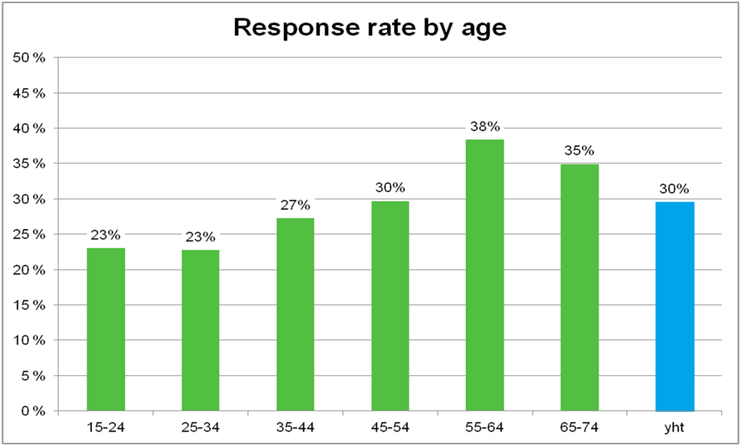

**Figure 5.** The response rate by education in LFS data collected by web (October 2013).

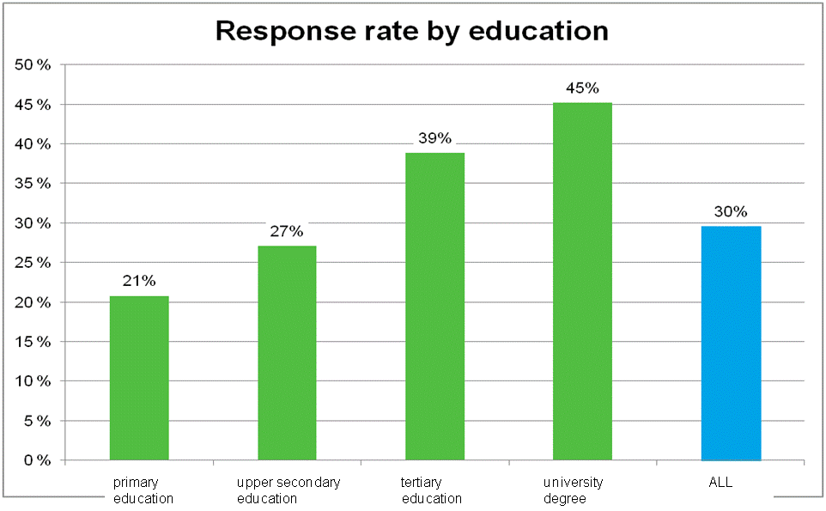

## **4. The main indicators of LFS**

Employment rate and unemployment rate are among the most closely followed economic indicators in Finland. In our web pilot study there were no statistically significant mode effects on employment status between the results from web data collection and telephone interview (official LFS), as the confidence intervals do overlap (Table 1, Fig 9). The estimates for unemployed populations were higher based on the data of web pilot, which gives unemployment rate of 8,2% whereas the telephone interview data produces 7,4% .

One reason for the absence of mode effect could be that the data in our web pilot was rather small. Nevertheless, even non-significant effects are interesting based on the very important status of this statistics.

To explain why there are more employed and unemployed person and less inactive persons in the web pilot data than in official LFS, we analyzed more closely the response patterns to some questions. It seems, that not-employed respondents in web data collection tend to answer more often that they have been looking for a job as compared to the respondents for the same question in telephone interview (*χ2*= 6.91, *p* = .01). The effect is even larger for employed respondents (*χ2*= 57.20, *p* = .0001).

**Table 1.** The unemployment rate and CI (95 %) in LFS data collected by web and by telephone interview (October 2013).

|  |  |  |
| --- | --- | --- |
|  | Web Data Collection | Telephone Interview |
| Unemployment Rate | 8,2% | 7,4% |
| 95% Confidence Interval | 6,6% | 6,1% |
| 9,9% | 8,8% |
| (n) | (2,345) | (2,570) |

**Figure 6.** The main indicators of LFS: Estimates and CI (95 %) for employed, unemployed, active and inactive population in LFS data collected by web and telephone interview (October 2013).

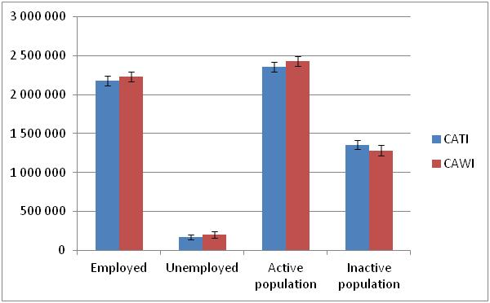

However, it is difficult to say whether the difference in the results is due to mode effects or greater selection bias in web data collection. We will analyze this further by adding more variables to weighting frame and trying to increase the similarity of these two data.

## **5. Number of Hours Worked**

One of the main aims of our web pilot study was to analyze whether the way to ask has some effect to the results of survey. We offered, for example, to the respondents two different way to report the hours they worked at the reference week. One half of the sample (group A) where asked total hours, and minutes per week with one question (Fig 7a). This is the way we asked it in the telephone interview, too. The other part of sample (group B) got a questionnaire where the total working hours were asked with seven separately questions, the grid format (Fig 7b).

**Figure 7a.** Layout for the “one question” -format of asking the working hours 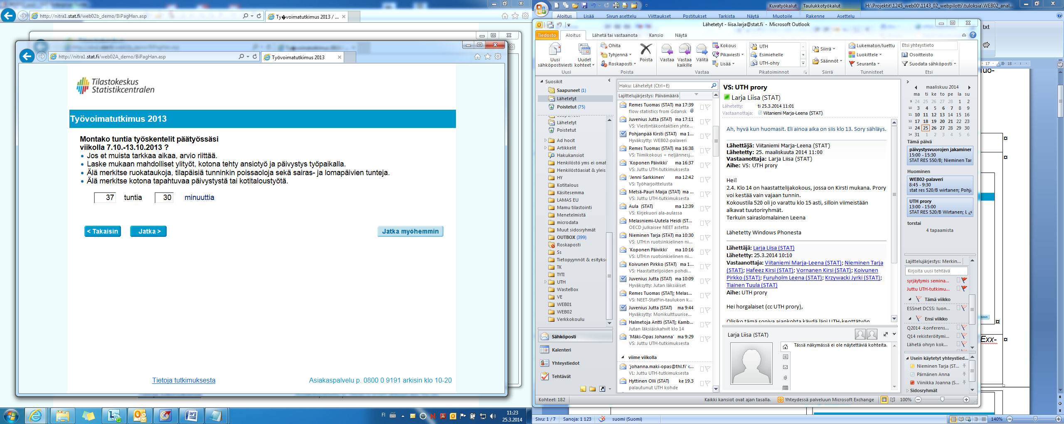

___ hours ___ minutes

“How many hours did you work in your main job during the week 7.10.-13.10.2013?

**Figure 7b**. Layout for the “grid”-format of asking the working hours

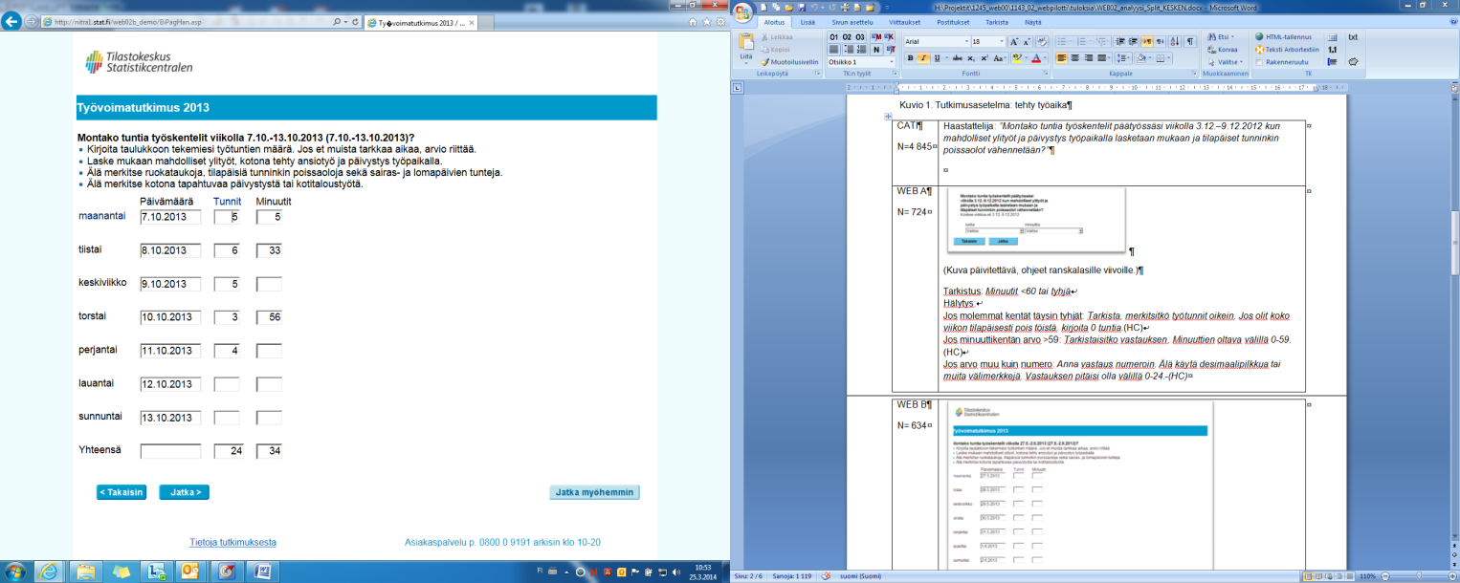

Date Hours Minutes

Monday 7.10.2013 ___ ___

Tuesday 8.10.2013 ___ ___

Wednesday 9.10.2013 ___ ___

Thursday 10.10.2013 ___ ___

Friday 11.10.2013 ___ ___

Saturday 12.10.2103 ___ ___

Sunday 13.10.29013 ___ ___

Total ___ ___

“How many hours did you work in your main job during the week 7.10.-13.10.2013?”

In our experience people tend, for example, to forget official holidays and other absences from work when answering to the question on actual working hours. However, in the telephone interview the interviewer can remind the respondent on occurrence of official holidays. In the cognitive pretest, we found also that in web data collection people tended to invest more effort on recalling the working hours when the hours were asked separately for each day in a grid form.

The results from our web survey showed that the respondents who answered using one question format reported on average less hours (35,5 hours, n = 703) than the respondents faced with grid-form question (36,2 hours, n = 626). This was surprising, as it was anticipated that grid-form would decrease reported working hours as people would better remember their absences. However, the difference was not statistically significant (Fig 8).

In the telephone interview the average amount of working hours was exactly the same (36,2 hours, n = 1316) as respondents told in grid form condition. The result points towards functional equivalency, meaning that we might need different kind of question format to different modes in order to produce similar results.

Although the differences between the different questions were not statistically significant, we recommend the grid form question to ensure better functional equivalency of results from web data collection and telephone interview.

It was observed from the paradata that completing the grid form question took on average three times as long as the one question -condition, but it was interpreted also as a sign of people investing in memorization and hence better quality.

**Figure 8.** Hours worked during the reference week among respondents of web data collection (one question, grid form) and respondents of telephone interview, weighted average of those who worked 1‒98 hours and CI (95%).

## **6. Conclusions**

The experience from the web pilot study of LFS encourage us to keep on developing LFS mixed mode design in Finland. The response rate of the web pilot was quite good, 30%. We estimate, that although managing mixed mode data collection process is expensive, adding web data collection would reduce total data collection costs in surveys like LFS, where the samples (and hence the amount of interviewing work) are large.

We learned also that there could be some mode effect in the main estimators of LFS, even the differences in the main indicators of LFS were not in this pilot survey statistical significant. Based on the very significance of LFS, the mode effect should be studied more. The reason for differences in employment status may be due to either mode-effects or selection bias, for example.

We learned also, that with careful question and questionnaire designing you can diminish the power of mode. For working hours we recommend grid form question in order to achieve better functional equivalency, and hence better comparison between the web data collection and telephone interview.

Anyway, the mixed mode data collection is coming to be a normal part of statistical process, and web questionnaires are required by respondents even now. We need to update our knowledge and proceedings for that. The change of the mode of data collection will cause also some challenge for communication.

## **References**

[1] Järvensivu, M. ‒ Kallio-Peltoniemi, M. ‒ Larja, L. (2014), The ESSnet project on Data Collection for Social Surveys using Multiple Modes. The pre-testing report of Statistics Finland. April 2014.

[2] Pohjanpää, K. (2014), The ESSnet project on Data Collection for Social Surveys using Multiple Modes. The report of web pilot study of LFS (WPIII)of Statistics Finland. May 2014.

[3] Larja, L. ‒ Taskinen, P. (2014), Mixed mode in LFS: questionnaire design and mode-effects. 9th Workshop on Labour Force Survey Methodology Rome, 15th and 16th of May 2014. Statistics Finland.

1. Many of my colleagues, e.g. Liisa Larja, Pertti Taskinen, Saara Oinonen, and Marika Jokinen have also taken part to the analyzing of the results. The results are reported e.g.in Workshop on LFS Methodology [3], too.