Toward harmonisation of survey questions on housing
Vlasta Zucha, Statistics Austria, Vienna
Richard Heuberger, Statistics Austria, Vienna
Currently there are three major surveys at the department for social statistics at Statistics Austria: the Microcensus, the Household Budget Survey and EU-SILC. Each of them includes questions on housing. The survey questions refer to similar housing characteristics, but vary according to the legal frameworks, context, aim and interest of the particular survey. Concurrently, questions on housing of each survey refer to the questions of the other surveys – be it as reference mark with regard to data quality or be it as donor dataset for the estimation of imputed rents. Thus the interrelations of the three datasets motivated efforts to harmonise a set of questions on housing within these surveys.
The paper will explain the motivation, challenges, procedures and gains of the harmonisation. It will elaborate on the various measures to ensure reasonable modifications of questions in all of the three surveys and draw some generalisations on harmonisation for other surveys.

Introduction
At least three surveys conducted by Statistics Austria deal with questions on housing, housing costs and housing conditions: the Microcensus, EU-SILC and the Household Budget Survey (HBS). Each of the three surveys is interested in particular aspects of housing. The main aim of the Microcensus Housing Survey is the general reporting on housing in Austria. The focus of the HBS is housing in the context of the consumption structure of private households. EU-SILC is mainly interested in housing conditions and housing costs within the scope of a survey concerned with living conditions of private households in Austria. Though these surveys are interested in different aspects of housing, quite many variables cover similar areas: tenure status, type of building, floor space – to mention just a few. But only some of them were formulated in a similar way. Furthermore, similarities between the characteristics and variables were not established and handled in a structured way so far.
The motivation to start a process of harmonising housing characteristics and analyse the possibilities of harmonisation was twofold. First, the three mentioned surveys reveal strong interrelations. They all cover housing characteristics and the Microcensus serves as donor dataset for EU-SILC and the HBS. And second, practical issues conducting surveys with interrelated topics (like interviewer trainings) were another important factor initiating the process of harmonisation.
Looking at a conventional survey process producing social statistics, harmonisation can be applied at three stages – inputs, processes or outputs. Thus, measures can be taken with regard to measurement issues, modes of survey administration and data analysis.
In the particular case of Microcensus, EU-SILC and HBS, the aim was not to come up with completely standardised national survey questions, but to harmonise highly interdependent questions with regard to analysis and reporting. Thus, the focus was on harmonising measurement issues primarily. The modes of survey administration were not in the focus of the harmonisation process started in the year 2013.
In literature, three harmonisation strategies referring to time and target of the process are distinguished: input harmonisation, ex-ante output harmonisation and ex-post output harmonisation [1, 2]. The strategies range from input harmonisation including the complete harmonisation of concepts, instruments and survey process to output harmonisation focusing on aggregated data. The harmonisation process of Microcensus, EU-SILC and HBS illustrated in this paper represents an input harmonisation focusing primarily on the measurement instrument and less on the administrative procedures of the surveys.

Challenges of harmonisation
The Microcensus, EU-SILC and the HBS are established and continuous surveys (quarterly, annually, every 5 years) which produce time series for special topics. Furthermore, these surveys are interrelated and linked with other surveys and statistics of Statistics Austria. Therefore, some challenges have to be met and a systematic approach has to be found.
To better understand the framework of harmonisation the different aims and interests of the Microcensus, EU-SILC and the HBS will be illustrated – in general and with regard to housing statistics. Furthermore, the surveys are based on different legal frameworks and – what is even more decisive – different types of legal frameworks, because housing characteristics and variables there are defined to different degrees.
The Austrian Microcensus Housing Survey is conducted within the framework of the Labour Force Survey (LFS). It is a household sample survey providing quarterly results on labour participation and housing. Each quarter more than 20.000 households are asked about their housing situation and housing costs by means of computer assisted personal or telephone interviews [3]. The LFS-part of the Microcensus provides quarterly and annual information on employment and labour participation as well as on persons outside the labour force. It also covers information about the structure of families and households. The questionnaire on housing allows general reporting on housing in Austria with detailed analysis of the housing situation in each federal state of Austria (Bundesland), stock of dwellings and housing costs of rented dwellings (see figure 1).
The legal base of the Austrian Microcensus is the national regulation on the organisation of a labour force and housing sample survey (EWStV 2010 – Erwerbs- und Wohnungs-statistikverordnung 2010). The housing characteristics which are asked in the survey are specified by this regulation in detail. The survey questions on housing are implemented in almost the same formulations since 2004. In addition, participation in the Microcensus is obligatory for the sampled households. Therefore, no further variables and characteristics besides those listed in the regulation can be asked within the obligatory part of the Microcensus.
EU-SILC is the European Union Statistic on Income and Living conditions. In Austria about 6.000 households are sampled. EU-SILC, together with the LFS, is one of the pillars of the social statistics of the European Statistical System. EU-SILC is regulated by a national regulation on statistics on income and living conditions (ELStV) and EU-regulations. It is output-harmonised, i.e. EU-regulations provide the methodological and definitional framework and definitions of the target variables. This framework defines the minimum requirement of the national survey and questionnaire, leaving a certain area of discretion for nationally required questions and the design of the final national questionnaire. As part of a cross-national comparative survey EU-SILC in Austria also requires the coordination with other German-speaking countries concerning the wording (see figure 1).
The Household Budget Survey provides information on the consumption expenditure of private households and is conducted as sample survey among private households. The results give an insight into the consumer habits of Austrian households and provide information on the living standard and living conditions of different social groups [4]. The HBS is carried out every five years; the next survey will be conducted in 2014/15. With regard to housing statistics, the focus is on housing in the context of the consumption structure of private households and in particular for different household types. The legal framework of the HBS is the EU regulation for HICP which does not specify housing characteristics in detail.

Figure 1: The main contents of the surveys and their legal frameworks
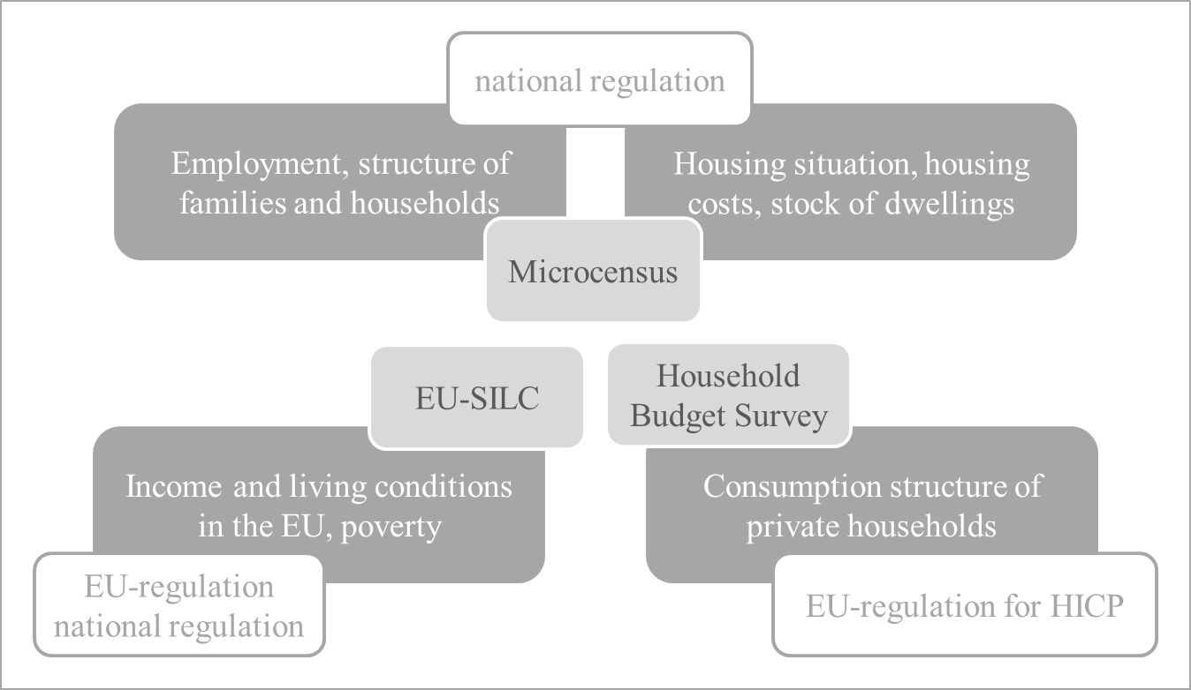

To sum up, harmonisation of housing characteristics has to consider different aims and core topics of the three surveys, as well as different legal requirements and specifications. However, there are not only different interests and frameworks of these surveys. They also show a high level of interrelations and interdependences. This does demand harmonisation on the one hand, but also makes harmonisation difficult on the other.
The questions on housing in each survey refer to the questions of the other surveys, in two particular aspects. On the one hand, the Microcensus is the reference mark with regard to data quality for EU-SILC and the HBS. On the other hand, it also is the donor dataset for the estimation of imputed rents (see figure 2). Furthermore, the HBS is the donor dataset for maintenance costs in EU-SILC. The average of the maintenance costs is used for the calculation of the total household costs in EU-SILC.
As shown in figure 2, there are further interdependences within housing statistics and essential indicators produced by Statistics Austria. The Microcensus also serves as donor dataset for the estimation of imputed rents for the National accounts.
In addition, the Microcensus is donor dataset for housing costs of the consumer price index (CPI) as a measure of general price trends and of inflation in Austria as well as the harmonised index of consumer prices (HICP) which is the base for a comparative measurement of inflation in Europe. Rents and running costs of rented dwellings of the Microcensus are integrated in these monthly indices.

Figure 2: Interdependences of the main surveys and projects using data on housing within Statistics Austria
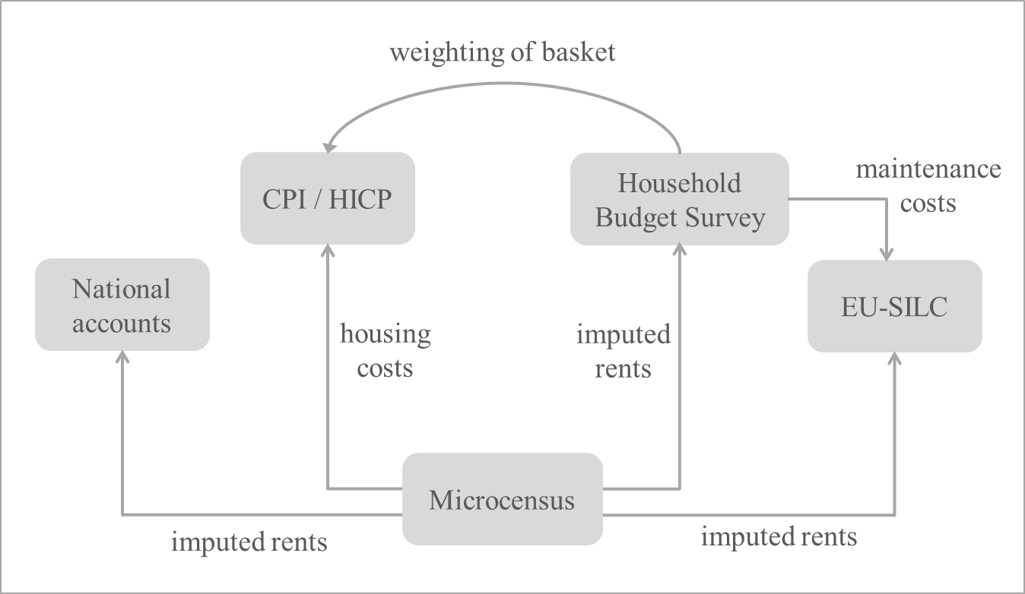

Harmonising questions – harmonising variables
The aim of harmonising housing questions was not to come up with completely standardised national survey questionnaires for housing, but to harmonise those questions which are highly interdependent with regard to analysis and reporting. It was not necessary (and possible) to construct exactly the same measurement instrument to cover the topic “housing”, but to adapt survey questions and documents.
The approach to harmonise housing questions of Microcensus, EU-SILC and HBS was set up through a process linked to three different levels. These levels (partly) cover the measurement issues, the administration mode and the data analysis of the surveys:
- Conceptual level: Which concepts are to be measured? What is the aim of measurement? Who are the users of the data and what they use the data for?
- Technical level: How to measure the concept? How to formulate the questions? In which context are the questions asked? What kinds of warnings or signals are used during the interview?
- Empirical level: To what extent the data show similarities so far? Which differences or problems do the results of the surveys and empirical distributions indicate so far?
To include all these levels in the harmonisation process it was necessary to collect and compare different documents, processes and results of the considered surveys. First of all, the legal frameworks and regulations of Microcensus, EU-SILC and HBS were examined. Especially those concepts in the focus of harmonisation were inspected for similarities and dissimilarities.
After comparing the requirements and specifications for measurement, the existing measurement instruments themselves were examined. The relevant questionnaires and documents were analysed in many respects: not only the questions themselves, the formulation and terms, but also the annotations for interviewers and other documents for field work, the context of the questions and administrative processes were included. The configuration of CATI-/CAPI-programming and warnings (hard and soft errors), which are part of the quality management during the interviews, were compared.
In a final step, the statistical distributions of the surveys were examined to support the empirical base for the differences and similarities that have occurred in the three surveys so far.
In addition, a respondent debriefing was used in the harmonisation process. It was conducted within the Microcensus Housing Survey in the third quarter of the year 2013 in order to evaluate the survey questions and to gather further knowledge about the respondent’s information on the topic. The debriefing was implemented in the CAPI-interviews of Microcensus and more than 700 interviews were available to analyse the questions about floor space and housing costs.

An example for successful harmonisation - number of rooms per dwelling
To better illustrate the harmonisation process of housing questions and the result of harmonisation, we will describe one particular example. The characteristic “number of rooms per dwelling” is included in the three surveys. It represents an important variable for the construction of different indicators on housing. For example, it is used as indicator describing the size of dwellings. Furthermore, it is used to analyse the space deficit on the basis of the Microcensus Housing Survey. The variable “number of rooms per dwelling” is also needed to calculate imputed rents of EU-SILC and the HBS on the basis of the Microcensus.
Up to the year 2013 the characteristic “number of rooms per dwelling” was asked in different ways: (a) Microcensus and Household Budget Survey covered the number of rooms including kitchen with more than 4 square metres and (b) EU-SILC surveyed the number of rooms without kitchen.
The harmonisation started with the examination of legal frameworks and regulations. Thereafter, the external and internal usage of the data as well as the linkage to other statistics was considered. On this basis the purpose of the measurement and the extent of equivalence of the underlying concept were specified. Not only the question itself, but also the form and helping texts for interviewers, annotations and warnings in the programming of the questionnaires differed up to the year 2013.
The additional questions of the respondent debriefing of the Microcensus helped to understand the way the respondents answer the questions in the Microcensus and the information they use to answer the question. Additionally, the statistical distributions of the variable in the Microcensus, EU-SILC and the HBS were analysed.
Based on this process, it was finally decided to establish not only the same measurement instrument, but also the same helping texts and annotations for interviewers as well as similar warnings in the interviewing process. Therefore, two survey questions were constructed to cover both the “former” and the “new” versions of the indicator in the three surveys. The first question which has been implemented in the surveys starting in 2014 requests the number of rooms without kitchen. The second question refers to the type and sizes of the kitchen (see table 1). The harmonisation also includes remarks and annotations for interviewers and warnings in the CATI-/CAPI-programming. The context of the question and structure of questionnaires of the three surveys, however, was not changed.
These changes ensure that Microcensus, EU-SILC and the HBS now include a similar measurement of the characteristic “number of rooms per dwellings” and still allow continuing the time series of each survey. The comparability and coherence within time series of the particular surveys as well as between the separate datasets is guaranteed by implementing two questions on this measurement concept.

Table 1: Variable “number of rooms” – former and new version
Microcensus 2013  Household Budget Survey 2009 | Number of rooms including kitchen with more than 4 sqm
EU-SILC 2013 | Number of rooms without kitchen
Microcensus 2014  EU-SILC 2014  Household Budget Survey 2014 | Number of rooms without kitchen  Type and size of kitchen

In the case of the variable “number of rooms per dwelling” the harmonisation process was successful in establishing the same questions, the same documents for the interviewing process (helping texts and annotations for the interviewers) and similar warnings during the interview situation. But not all survey questions on housing could be harmonised in such a comprehensive way. A set of questions was harmonised, though the extent of harmonisation differs:
- Only annotations were harmonised, the questions were not changed, because they were asked in the same way even before harmonisation was started (e.g. period of construction of the building, number of dwellings per building).
- The formulation of the question and other survey parts and documents (additional text which is displayed for interviewers on the screen, annotations for the interviewers, warnings) were harmonised: e.g. living space, number of rooms per dwelling and type of kitchen (see above), tenure status.
- In some cases, annotations were harmonised, the way of asking the question was not changed and still differs (e.g. equipment of the dwellings regarding sanitary facilities, heating installations of the dwelling, garage/parking).
- Primarily due to imputed rents, a few questions were added: questions on the outdoor area of the dwelling and on the elevator in the building were added to the Microcensus and reformulated in EU-SILC to extend the data base for imputed rents.
- There are still some characteristics which were not harmonised, especially those measuring housing costs.

Limitations of harmonisation and areas left out
Though it is convincing that all surveys should include the same questions concerning a particular topic, the harmonisation of survey questions has limitations. Harmonisation is not necessarily reasonable when the topic is largely the same, but aims of the questions are different in the surveys. One example would be the type of heating in EU-SILC on the one hand and in the Microcensus and HBS on the other. EU-SILC aims to measure facilities of the household with respect to the living standard and is therefore interested in the heating facility of the higher standard (in case of more than one type of heating). The HBS and to a certain extent the Microcensus, however, is interested in the structure of household costs and therefore is more interested in the heating facility mainly used by the household. Hence, EU-SILC is interested in what is available for the household, whereas HBS and Microcensus focuses on what is used by the household. In most of households there would not be any difference between these two approaches, but for the remaining households this is the difference that matters.
With regard to some other survey questions the legal regulations of the surveys prohibit to change the content of the question and consequently impede harmonisation. Concerns about breaks in time series that would occur when the content of particular questions are changed could sometimes be even more effective than legal restrictions – and hence prevent harmonisations. These concerns also might occur if the harmonisation with a particular survey endangers the comparability with other surveys or statistics.
In sum, harmonising is necessary, reasonable and possible, but not under all circumstances. These circumstances are defined by an evaluation of the trade-off connected to the harmonisation and an account of the requirements of each particular question under consideration. As compelling as harmonisation sounds in most of the cases it also means a change of a continuously conducted and established (part of a) survey. And these changes directly or indirectly might lead to problems. One example is the measurement of housing costs in the Microcensus: any change of these variables would lead to significant changes in the calculation of the CPI which is partly derived from these costs.
Concerning the topic of housing in the Microcensus, EU-SILC and the HBS, several areas have been left out. Particularly questions concerning housings costs were considered too complex, demanding and specific to harmonise in this first round and within the strategy of input harmonisation. Housing costs are of particular importance for all three surveys and each survey is interested in specific aspects of housing costs. Complex and legally sophisticated definitions and concepts additionally complicate harmonisation attempts within this area.

Next steps
The major steps in the harmonisation process of the Microcensus Housing Survey, EU-SILC and the HBS took place in 2013. In the first half of the year, the comparison and analysis on conceptual, technical and empirical level was conducted. In the second half of the year, changes were implemented into the questionnaires and the administrative processes of the surveys. The harmonised measurement instruments are fielded in 2014 within the Microcensus and EU-SILC, so that at the end of this year they can be analysed and used at least for these two surveys. The field work of the HBS will start at autumn 2014 and last until autumn 2015.
Concurrently, the reporting and publication on housing is being re-established within Statistics Austria. E.g. the main report on housing which was solely based on the Microcensus Housing Survey so far [5] will be changed into a general housing report which will include several surveys and statistics on housing. Therefore, also data analysis and reporting will be harmonised – first of all Microcensus and EU-SILC, but also the HBS at a later date. The presentation and description of results within one report will only be successful if the differences and similarities of concepts, definition and terms will be communicated in an adequate and user-friendly way.

Conclusions
The harmonisation of housing questions in the Microcensus, EU-SILC and the Household Budget Survey were the first steps towards increased interdependence of surveys at Statistics Austria. The focus so far was restricted to a handful of variables within the scope of an input harmonisation strategy; other housing related variables (mainly covering costs) are not harmonised yet – for a good reason. Nonetheless, this process of harmonisation will not come to a halt. The next steps will include an evaluation of the results of the harmonised survey waves and reconsidering harmonising the financial dimension of housing.
What has been learned from the process? Harmonisation, particularly the reconcilement of different interests, different aims and different legal requirements is a cumbersome and time-consuming process. Additionally, interventions in and changes of long-running continuous surveys might create problems for time series, interconnections with other statistics and possibly with legal frameworks. Yet, the gains of the process compensate for the difficulties. Harmonised variables allow for an easier and methodologically sound comparison of the surveys (improving the control of survey quality) and increase the use of datasets matching these harmonised datasets (e.g. in a project, that matches the income variables of EU-SILC with the larger sample of the Microcensus).
The process of harmonisation described in this paper in some way parallels the similar process of establishing a set of social core variables on European level in the main surveys of the European Statistical System (ESS). These social core variables are focused on the socio-demographic and the labour market dimension, and deliberately leave the housing dimension out. The aim of this set of variables is that all concerned surveys should include equivalent variables (similar definitions, wording and so on) to allow for a better interconnection of these surveys, for example for statistical matching. Finally, one objective could be reducing the total number of surveys and sample sizes (saving costs and lowering the burden for respondents). However, the process of harmonising the housing questions in Austria stands in a greater context of increased coordination of surveys, keeping methodological questions on comparability in mind.

References
[1] Ehling, M./Rendtel, U. et al. (2006): Synopsis. Research Results of Chintex - Summary and Conclusions, Wiesbaden, Statistische Bundesamt.
[2] Hoffmeyer-Zlotnik, J. (2008), Harmonisation of Demographic and Socio-Economic Variables in Cross-National Survey Research, Bulletin de méthodologie sociologique, Vol. 98, 5-24.
[3] STATISTIK AUSTRIA (2013), Standard-Dokumentation: Metainformationen (Definitionen, Erläuterungen, Methoden, Qualität) zu Mikrozensus ab 2004, Arbeitskräfte- und Wohnungserhebung.
[4] STATISTIK AUSTRIA (2013), Standard-Dokumentation: Metainformationen (Definitionen, Erläuterungen, Methoden, Qualität) zur Konsumerhebung 2009/10.
[5] STATISTIK AUSTRIA (2013), Wohnen 2012: Ergebnisse der Wohnungserhebung im Mikrozensus, Jahresdurchschnitt 2012.

  - Questionnaires of Microcensus, EU-SILC and Household Budget Survey:
EU-SILC 2013: http://www.statistik.at/web_de/static/fragebogen_eu-silc_2013_070064.pdf
EU-SILC 2014: http://www.statistik.at/web_de/static/fragebogen_eu-silc_2014_075226.pdf

Microcensus 2014:
http://www.statistik.at/web_de/static/mz-fragebogen_1.quartal_2014_074703.pdf

Household Budget Survey 2009/2010:
http://www.statistik.at/web_de/static/konsumerhebung_200910_codebuch_fuer_detaillierte_mikrodaten_057566.pdf

