New models of governance and coordination in complex statistical systems
Stephan Moens, Statistics Belgium
Abstract
Over the last decades, the statistical system of Belgium has evolved from a monolithic system to a very complex system, decentralized functionally as well as regionally. This poses problems of governance, coordination and quality control, which have to be addressed carefully.
In the last reform of the State, it was decided to even further regionalise (“interfederalise”) statistics. The challenge now is to create a governance and coordination system that ensures quality, and is at the same time assured of enough political support at all levels of decision making.
Some models have been put forward to achieve this goal and are now under discussion on the political level. The paper discusses the advantages and disadvantages of these models and draws some preliminary conclusions from a Belgian and a European perspective.

- The Belgian statistical system
The statistical system of Belgium is a very complex one. It is the result of political decisions, related to the evolution of the Belgian federal system and to the economic governance of the state.
One should remember that Belgium was one of the first countries in Europe to install a modern system of official statistics in the 19th century. The precursors of the current statistical institutions were set up at Adolphe Quetelet’s instigation in early Belgium. The Statistical Bureau (1826) was the executive body and the Central Statistical Commission (1841) ensured the coordination of all statistical initiatives in Belgium.
The first census in Belgium was taken on 15 October 1846. An agricultural and industrial census was organized simultaneously. Census and surveys became more and more numerous and resulted in many publications. However, after Quetelet’s death in 1874, the interest in public statistics weakened. Only after World War I public statistics were thoroughly reorganized in Belgium.
The Bureau of General Statistics became the Office of General Statistics in 1925. This name changed in 1932 already and new missions were assigned. The Central Bureau of Statistics was from then on empowered to carry out large-scale censuses and surveys, to edit all statistical publications and to produce statistics. The 1936 Statistics Act introduced the obligation for private persons to respond to some surveys.
A second major reorganization took place after World War II. The National Statistical Institute (NSI) was created in 1946. In the same year the Central Statistical Commission was reformed and renamed to Higher Council of Statistics. The NSI produced a growing number of statistics within the framework created by the new Statistics Act of 1962.
In the last decades of the 20th century, a far-reaching reform of the State was set up. This resulted in a comprehensive regionalisation, where the majority of the competences of the State were attributed to the regions. I will not go into detail on this in itself very complex regionalisation but one aspect of it has to be stressed. This is the peculiarity that in the Belgian federal State structure, federal law does not overrule regional law. We will have to keep this in mind when we come to the legal context of the new statistical system. Up to this year however, official statistics were not regionalised. They remained a prerogative of the federal level. Notwithstanding, the regions have set up in recent times institutions to draw up official statistics on the regional level.
A second major shift came in 1994, when the federal government set up the National Accounts Institute. This institution gathers representatives from three important institutes, i.e. the NSI, the National Bank of Belgium and the Federal Planning Bureau. It is legally responsible for national, regional and satellite accounts, public finance statistics and foreign trade statistics, which formerly belonged to the exclusive scope of competence of the NSI. Within the NAI, the responsibilities are clearly defined: Statistics Belgium is responsible for the production of basic statistics, the NBB for national accounts, public finance statistics and foreign trade statistics, the FPB for satellite accounts and previsions. Within the NAI, there is free exchange of microdata; all partners are bound by the Statistics Act (including its confidentiality principles) and the CoP.
By Royal Decree of 20 November 2003 the “National Statistical Institute” was renamed to “Directorate General Statistics and Economic Information”, which last year was simplified to “Directorate General Statistics – Statistics Belgium”, to take into account its growing European and international dimension.
In 2006, again a new Statistics Act came into force. This act brought the functioning of Statistics Belgium in line with the most recent evolutions as regards privacy protection, administrative simplification and data exchange for scientific purposes.
Fig. 1 The Belgian Statistical System
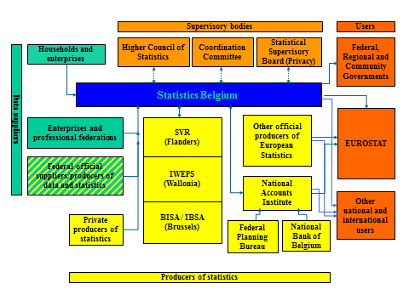
- The latest reform of the State
After the elections of 2010, a new round of reform of the State was initiated. For the first time, it included a chapter on official statistics. The Institutional Agreement of the Cabinet Di Rupo mentioned the “Interfederalisation of the National Statistical Institute” and the “Incorporation of the Regions in the National Accounts Institute”. For both changes, a Cooperation Agreement between the Federal State and the Regions would have to be concluded. However, the Institutional Agreement did not mention anything on the form of the “Interfederalisation” or on the content of the Cooperation Agreement.
In the meantime, the Cooperation Agreement is now concluded and legislative initiatives have been taken to fix the content of it in law. But before and during the negotiations, several models of cooperation and coordination were put forward, which all tried to organise the governance of the system, maximise its productivity, user orientation, cost-effectiveness and quality, and minimise the risks of the operation, while at the same time fulfilling the institutional and political agenda of the Agreement.
Even if the negotiated outcome did only partially feed on these models, they provide interesting material for the governance of complex statistical systems, especially in terms of quality.
- Coordination and quality in complex statistical systems
Complex statistical systems such as the Belgian one bear opportunities and risks. As regards quality, the opportunities reside mainly in specialisation and proximity. Specialisation (in functionally decentralised systems) is a guarantee for high-quality staff and good knowledge of the field. Proximity (in regionally decentralised systems) can be helpful with quality control in data collection and with assuring relevance.
But there are also risks. Regional decentralisation can lead to heavier political interference. Functional decentralisation is prone to diverging quality standards, which can be especially harmful if they occur within one production line, e.g. between basic statistics and the accounts and indicators that are derived from it.
The remedies to these risks are obvious: cooperation, coordination and quality assurance at the coordinating level. This can be done in a hierarchic structure, where the upper level coordinates and assures quality control (such as put forward in regulation 223) or in a network-like fashion, where all partners are jointly responsible for coordination and quality assurance.
- Governance models put forward to solve the Belgian problem
From 2011 on, with the negotiations on the reform of the State still ongoing, several governance models were put forward to solve the intricate problem of integrating the regional statistical offices into the statistical system without mitigating the delicate institutional balance that already existed. I will discuss the two main models put forward: a ‘minimalist’ model making as less adaptations as possible and mirroring the ‘interfederalisation’ of the NSI to the NAI model; and a ‘maximalist’ model creating a new cooperation structure with shared responsibilities.
The minimalist model
The minimalist model was based on the model already in place for the National Accounts Institute, because this had proven to be rather successful in terms of quality and coordination. Its main characteristics were:
- The NAI would stay in place, but the Regions would have their say on all levels.
- For all other official statistics, a parallel organisation would be created with the same characteristics as the NAI. Exactly like the NAI, it would be an ‘empty box’, without substantial budget or staff. There would be a board, where the statistical institutes at the federal and regional level would be represented with equal rights, and which would take all decisions regarding coordination, harmonisation of quality control and methodology, etc. This board would be assisted by scientific committees. The Chairman of the Board would be appointed on a rotation system and would act as Head of NSI in the sense of Regulation 223.

Fig. 2 The minimalist model
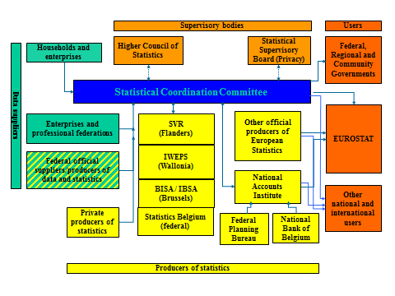
This model had the advantage of having been tested before within the NAI. As such, it seemed politically acceptable and could be easily implemented. On the other hand, it did not take into account the evolution in the discussion on the revision of Regulation 223 and it missed the opportunity to use the momentum of the Reform of the State to create a more future-oriented organisation form.
The maximalist model
The maximalist model tried to do exactly this: make use of the existing momentum. It designed a new cooperation model for the Belgian Statistical System, in line with the wish for more regionalisation and with the tendency towards a stronger coordination and quality control for the entire system. Its main characteristics were:
- A new distribution of competences
  - At the federal level: coordination, methodology (including standardisation of processes), quality control, representation on international forums, national accounts, analysis and studies on federal competences,…
  - At the regional level: regional statistics, analysis and studies on regional competences,…
  - Within a network of the federal and regional levels: data collection, ICT, data warehousing, relation to external databases,…
- Free exchange of microdata within the entire network
- Strong coordination and clearing structures. Creation of a new supervisory body (‘Council of the BSS’) with two chambers: a scientific chamber and a policy chamber, replacing the Higher Council and the Coordination Committee..
The main novelty was the network structure, where the federal and the regional level would have shared responsibilities and would closely cooperate to realise economies of scale and ensure common quality standards.

Fig. 3 The maximalist model

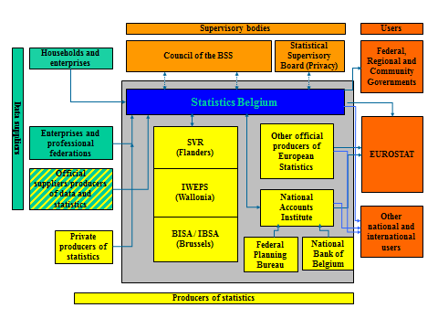
This model had several advantages: a clear delineation of competences and at the same time a strong cooperation between the levels; a strong coordination at the federal level; a shared responsibility for quality and a central management for quality control. On the other hand, it had the disadvantage of novelty: it was not tested and would need a long-term step-by-step plan with periodical evaluation. Moreover, it supposed a new institutional approach: up to now, the reform of the State had always been considered as a series of transfers of competences; now, the relationship between the institutional levels would need rethinking. As such, the political acceptability of the model was not ensured.

- The outcome of the reform of the State

The federal government decided to enter the negotiations with a lighter version of the minimalist approach. Due to strong demands of the regions for more influence within the system and to the demand of the federal level for a stronger coordination, a new coordinating body was created (“Interfederal Statistical Institute”), where the federal and the regional institutes are equally represented, with a rotating presidency. Up to now, it is unclear if this body will act as the NSI in the sense of Regulation 223. On the other hand, both the federal and the regional governments will provide budget and staff for coordinating activities.
The new structure has not yet been implemented (this is planned for 1 January 2016).

- Conclusions and outlook
Coordination is the key word to assure quality in complex statistical systems. However, there is more than one interpretation to that word. Up to now, the hierarchic approach has prevailed. One should however consider if network-like approaches are not equally strong or perhaps stronger in quality assurance, given that in such systems responsibilities are shared.
As to Belgium, the future will show if the governance model that was politically agreed will be robust enough to ensure high quality to tackle the statistical challenges of the future. It is quite certain that over time, the system will have to be adapted and strengthened. It will mainly depend on the willingness of all partners involved to safeguard independence and quality standards if the system will succeed.

